Unit #4: Quadratic - Highs and Lows (13 days + 2 jazz + 3 midterm summative evaluation days)

BIG Ideas:
- Investigate the three forms of the quadratic function and the information that each form provides.
- Using technology, show that all three forms for a given quadratic function are equivalent.
- Convert from standard (expanded) form to vertex form by completing the square.
- Sketch the graph of a quadratic function by using a suitable strategy. (i.e. factoring, completing the square and applying transformations)
- Explore the development of the quadratic formula and connect the value of the discriminant to the number of roots.
- Collect data from primary and secondary sources that can be modelled as a quadratic function using a variety of tools.
- Solve problems arising from real world applications given the algebraic representation of the quadratic function.

DAY | Lesson Title & Description | 2P | 2D | Expectations |  | Teaching/Assessment Notes and Curriculum Sample Problems
1 | Graphs of quadratics in factored Form  - The zeros and one other point are necessary to have a unique quadratic function  - Determine the coordinates of the vertex from your sketch or algebraic model  Lesson Included | C  No  “a” | C | QF2.09  ✓ | sketch graphs of quadratic functions in the factored form f (x) = a(x – r )(x – s) by using the x- intercepts to determine the vertex; |  Computer and data projector (Optional)
2 | Investigating the roles of a, h and k in the Vertex From  - Investigate the roles of “a”, “h” and “k”  - Apply a series of transformation to y=x² to produce the necessary quadratic function  Lesson Included | N | C | QF2.05  ✓ | determine, through investigation using technology, and describe the roles of a, h, and k in quadratic functions of the form f (x) = a(x – h)² + k in terms of transformations on the graph of f(x) = x² (i.e., translations; reflections in the x-axis; vertical stretches and compressions) | Computer Lab  Sample problem: Investigate the graph f (x) = 3(x – h)² + 5 for various values of h, using technology, and describe the effects of changing h in terms of a transformation.
3 | Sketching quadratics functions in vertex form  - Apply a series of transformation to y=x² to produce the necessary quadratic function  Lesson Included | N | C | QF2.06  ✓ | sketch graphs of g(x) = a(x – h)² + k by applying one or more transformations to the graph of f (x) = x² | Computer and data projector  Sample problem: Transform the graph of f (x) = x² to sketch the graphs of g(x) = x² – 4 and h(x) = –2(x + 1)²
4 | Changing from vertex form to standard (expanded) form  - Verify using technology that both forms are equivalent | N | N | QF2.07  ✓ | express the equation of a quadratic function in the standard form f(x) = ax² + bx + c, given the vertex form f(x) = a(x – h)² + k, and verify, using graphing technology, that these forms are equivalent representations |  or  Sample problem: Given the vertex form f(x)= 3(x – 1)² + 4, express the equation in standard form. Use technology to compare the graphs of these two forms of the equation.
5,  6 | Completing the Square  - Use algebra tiles to investigate procedures  - Verify using technology that both forms are equivalent  - Develop a procedure to complete the square using algebra  Lessons Included | N | C | QF2.08  ☑ | express the equation of a quadratic function in the vertex form f (x) = a(x – h)² + k, given the standard form f(x) = ax² + bx + c by completing the square (e.g., using algebra tiles or diagrams; algebraically), including cases where is a simple rational number (e.g., ½ , 0.75), and verify, using graphing technology, that these forms are equivalent representations; |  Algebra Tiles Day 5  Day 6
7 | Gathering information from the three forms of quadratic functions  - Use inspection to gather information | N | N | QF2.10  ✓ | describe the information (e.g., maximum, intercepts) that can be obtained by inspecting the standard form f (x) = ax² + bx + c, the vertex form f (x) = a(x – h)² + k, and the factored form f (x) = a(x – r)(x – s) of a quadratic function;
8 | Sketching the graph of quadratic functions in standard form  - Use a suitable strategy to gather information to construct the graph | N | R | QF2.11  ✓ | sketch the graph of a quadratic function whose equation is given in the standard form f (x) = ax² + bx + c by using a suitable strategy (e.g., completing the square and finding the vertex; factoring, if possible, to locate the x-intercepts),and identify the key features of the graph (e.g., the vertex, the x- and y-intercepts, the equation of the axis of symmetry, the intervals where the function is positive or negative, the intervals where the function is increasing or decreasing).
9 | “CAS”ing out the quadratic formula  - Explore the development of the quadratic formula using CAS  - Apply the formula to solve equations using technology  Lesson Included | N | R | QF1.06  ✓ | explore the algebraic development of the quadratic formula (e.g., given the algebraic development, connect the steps to a numerical example; follow a demonstration of the algebraic development, with technology, such as computer algebra systems, or without technology [student reproduction of the development of the general case is not required]), and apply the formula to solve quadratic equations, using technology; | CAS
10 | Relating roots and zeros of quadratic functions  - X-intercepts (zeros) and roots are synonymous  - The sign of the disciminant determines the number of roots | N | N | QF1.07  ✓ | relate the real roots of a quadratic equation to the x-intercept(s) of the corresponding graph, and connect the number of real roots to the value of the discriminant (e.g., there are no real roots and no x-intercepts if b² – 4ac < 0);
11 | Solving quadratic equations  - Solve equations using a variety of strategies  - Describe advantages and disadvantages of each strategy | N | C | QF1.08  ✓ | determine the real roots of a variety of quadratic equations (e.g., 100x² = 115x + 35), and describe the advantages and disadvantages of each strategy (i.e., graphing; factoring; using the quadratic formula) | Sample problem: Generate 10 quadratic equations by randomly selecting integer values for a, b, and c in ax² + bx + c = 0. Solve the equations using the quadratic formula. How many of the equations could you solve by factoring?).

12,  13 | Nano Project or Fuel Fit  - Collect data from primary or secondary sources without technology  - Determine the equation of a quadratic model for the collected data using technology  - Solve problems from real world applications given the algebraic representation of a quadratic function  Lessons Included | C | C | QF3.01  ✓ | collect data that can be modelled as a quadratic function, through investigation with and without technology, from primary sources, using a variety of tools (e.g., concrete materials; measurement tools such as measuring tapes, electronic probes, motion sensors), or from secondary sources (e.g., websites such as Statistics Canada, E-STAT), and graph the data | Sample problem: When a 3 x 3 x 3 cube made up of 1 x 1 x 1 cubes is dipped into red paint, 6 of the smaller cubes will have 1 face painted. Investigate the number of smaller cubes with 1 face painted as a function of the edge length of the larger cube, and graph the function.)  Sample problem: When a 3 x 3 x 3 cube made up of 1 x 1 x 1 cubes is dipped into red paint, 6 of the smaller cubes will have 1 face painted. Investigate the number of smaller cubes with 1 face painted as a function of the edge length of the larger cube, and graph the function.)  or
12,  13 |  | N | N | QF3.02  ✓ | determine, through investigation using a variety of strategies (e.g., applying properties of quadratic functions such as the x-intercepts and the vertex; using transformations), the equation of the quadratic function that best models a suitable data set graphed on a scatter plot, and compare this equation to the equation of a curve of best fit generated with technology (e.g., graphing software, graphing calculator);
12,  13 |  | C | C | QF3.03  ✓ | solve problems arising from real-world applications, given the algebraic representation of a quadratic function (e.g., given the equation of a quadratic function representing the height of a ball over elapsed time, answer questions that involve the maximum height of the ball, the length of time needed for the ball to touch the ground, and the time interval when the ball is higher than a given measurement)
14 | Instructional jazz day  Note: This day may be located throughout the unit as needed.
15,  16 | Midterm summative assessment performance task  Note: Two possible performance tasks are included (A Leaky Problem or Bridging the Gap) |  |  |  |  | (Day 16)  Note:  The two midterm summative performance tasks are in the file Midterm SP Task.
17 | Unit Review
18 | Pencil and paper summative assessment on expectations from this unit not covered in the summative performance task.

Unit 4 : Day 1: Graphs of Quadratics in Factored Form |  |  |  | Grade 11 U/C
Minds On: 30 |  | Description/Learning Goals  - Activate prior knowledge on the factored form of a quadratic function  - Sketch graphs of quadratic functions in the factored form f(x) = a(x – r)(x – s)  - Determine the coordinates of the vertex using the graph or algebraic model |  | Materials  - BLM 4.1.1  - BLM 4.1.2  - Chart paper  - Markers  - Computer & data projector  - FRAME document
Action: 30
Consolidate:15
Total=75 min
Assessment
Opportunities
 | Minds On… | Small Groups → Discussion/Exploration  - In groups of three or four, students will use the graphic organizer (BLM 4.1.1) to activate prior knowledge on the properties of parabolas, the information they need to graph a parabola, the information they can gather from a quadratic equation in factored form and the steps they would need to determine the coordinates of the vertex.  - Groups will share their results with the class. The class will summarize the results on chart paper using a graphic organizer on chart paper and this will then be posted in the room.  - Optional: Use the Geometer’s Sketchpad prepared sketch with a data projector to demonstrate the information that can be obtained from a graph of an equation in factored form. |  | Ensure groups have students coming from both 2D and 2P in them.  Cooperative Learning Strategy  To share results each group can provide one piece of information. Continue cycling through the groups. If a group has no new information to share they may pass.  Geometer’s Sketchpad:  Barge.gsp  Students should correct each other’s work.
 | Action! | Pairs → Practice  - In pairs, students will complete the practice questions on BLM 4.1.2 using their activated prior knowledge.
 | Consolidate Debrief | Whole Class → Discussion  - Students share their graphs of quadratic equations from BLM 4.1.2  - Pose the following Guiding Questions:  - Are the two zeros enough information to make a unique graph?  - What other information do you need to make a graph unique?  - How does the value of a affect the graph?  Mathematical Process Focus: Reflecting ( In their journals students will reflect on the new concept and correct their partner’s answers.
Journal |  | Home Activity or Further Classroom Consolidation  - Assign further practice questions as needed.  - Update FRAME graphic organizer document with information from today’s lesson.  - Have students write in their journals using one or more of the following prompts:.  - What patterns did you see when the value of a changed?  - How can you determine from the factored form if the sketch will open up or down?  - How can you determine the coordinates of the vertex given the factored form?

4.1.1 Graphs of Quadratic Functions in Factored Form: Properties

In groups, use the graphic organizer to gather information for graphing quadratic functions in factored form.

Properties:  y = a(x – r)(x – s) | Information needed to graph:
Rules/Methods: | Examples:

4.1.2 Graphs of Quadratic Functions in Factored Form: Practice

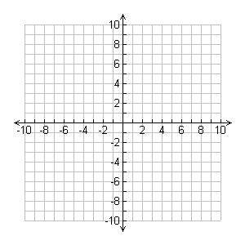
With a partner, use the information from your graphic organizer to graph the following quadratic functions:
y = (x + 3)(x + 5) | X-intercepts:
y = (x + 3)(x + 5) | Vertex:
y = 2(x + 1)(x – 3) | X-intercepts:
y = 2(x + 1)(x – 3) | Vertex:
y = -3(x – 3)(x + 1) | X-intercepts:
y = -3(x – 3)(x + 1) | Vertex:
y = $\frac{1}{2}\left(x−2\right)\left(x−4\right)$ | X-intercepts:
y = $\frac{1}{2}\left(x−2\right)\left(x−4\right)$ | Vertex:

Unit 4 : Day 2: Investigating the roles of a, h & k in the vertex form |  |  |  | Grade 11 U/C
Minds On: 20 |  | Description/Learning Goals  - Determine, through investigation using technology, and describe the roles of a, h, and k in quadratic functions in vertex form.  - Apply a series of transformations to the graph of f(x) = x² to produce the necessary graph |  | Materials  - BLM 4.2.1  - BLM 4.2.2  - BLM 4.2.3  - BLM 4.2.4  - Computer lab  - Data projector  - Optional Activity: Masking tape  - FRAME document
Action: 40
Consolidate:15
Total=75 min
Assessment
Opportunities
 | Minds On… | Whole Class à Check for Understanding  - In groups of four or five, students use the Graffiti strategy to summarize the roles of a, h, and k in quadratic functions of the form f(x)= a(x-h)² + k.  - Teacher can briefly assess the students understanding. |  | Students should be made aware of the difference between parameters and variables  Literacy strategy: Use Graffiti, (Think Literacy Cross-Curricular Approaches, Grades 7-12, p 26)  After the Minds On, class should move to the computer lab.  (ParabolaSlider.gsp)  Optional: Teacher could have students kinaesthetically demonstrate the roles of a, h, and k. Use tape to make a set of axes on the floor tiles of the classroom. Place seven students on the axes in the shape of x². Have the students transform for various values of a, h and k. After each question the students return to x² . Have the other students coach participating and students and .change student roles frequently.
 | Action! | Pairs → Investigate  - Using the ParabolaSlider pre-made Geometer’s Sketchpad sketch, students will investigate the role of a, h, and k in the quadratic function of the form f(x) = a(x – h)² + k and record their finding on BLM 4.2.1.  - Students demonstrate their understanding by completing BLM 4.2.2.
 | Consolidate Debrief | Whole Class → Summarizing  Mathematical Process Focus: Reasoning and Proving (Students to share how they completed the BLM 4.2.2 by recognizing the characteristics of each equation that give the values of a, h, and k, vertex, # of x-intercepts, domain and range).  - Discuss conclusions from the investigation and worksheet and have students summarize their results on BLM 4.2.3.  - Ensure that students understand the terminology  - Translations  - Reflections in the x-axis  - Vertical stretches or compression
Concept Practice |  | Home Activity or Further Classroom Consolidation  - Assign further practice questions as needed.  - Update FRAME graphic organizer document with information from today’s lesson.

4.2.1 Investigation – What are the roles of a, h and k?

With a partner and using the Parabola slider Geometer’s Sketchpad sketch, investigate the roles of a, h and k in the vertex form of the quadratic function. Record your findings.

Role of a:  As I increase the value of a (larger than 1), I notice…  As I decrease the value of a (smaller than -1), I notice…  As I change the value of a between -1 and 1, I notice…  y = a(x – h)² + k | Role of h:  As I increase the value of h, I notice…  As I decrease the value of h ( h becomes negative), I notice…  When the value of h is zero, I notice…
Role of k:  As I increase the value of k , I notice…  As I decrease the value of k (k becomes negative), I notice…  When the value of k is zero, I notice… | Other Observations:

4.2.2 Demonstrating understanding of the roles of a, h & k in y = a(x – h)² + k

In pairs, complete the following table.
Equation | Value  of a | Value  of h | Value  of k | Vertex  (h, k) | # of x-intercepts | Transformations Starting from y=x² | Domain  & Range
y = 3(x - 2)² + 1 | a = 7 | h = 2 | k = 1 | (2, 1) | None | - Vertical stretch by a factor of 3  - Translated 2 units right  - Translated 1 unit upwards | D: Set of real numbers  R: y ≥ 1
y = -2(x - 3)² + 3

y = $\frac{1}{2}$(x +1)² +5

y = 0.3(x + 2)² + 15

$y=−\frac{2}{3}(x−4)^{2}$- 8

y = 2x² + 9

y = -3(x + 5)²

4.2.3 Summarizing the roles of a, h & k in y = a(x – h)² + k

In a class discussion complete the following graphic organizer to summarize the roles of a, h and k.

Role of a:  Direction of Opening:  - When a is positive, the parabola opens __________________.  - When a is negative, the parabola opens__________________.  Shape:  - If a > 1 or a < -1, then the graph of y = a(x – h)² + k has an opening ______________________ than y = 1(x – h)² + k.  - If a is between -1 and 1, then the graph of y = a(x – h)² + k has an opening ______________________ than y = 1(x – h)² + k.  y = a(x – h)² + k | Role of h:  Properties:  - If h > 0, then the graph of y = a(x – h)² + k is translated horizontally h units to the _______________.  - If h < 0, then the graph of y = a(x – h)² + k is translated horizontally h units to the _______________ .  Relation to the Vertex:  - The value of h is the _____ - coordinate of the vertex.
Role of k:  Properties:  - If k > 0, then the graph of y = a(x – h)² + k is translated vertically k units ____________.  - If k < 0, then the graph of y = a(x – h)² + k is translated vertically K units ___________.  Relation to the Vertex:  The value of k is the _____ - coordinate of the vertex.  X-Intercepts:  - If k = 0, then the graph has ___________ zero (x-intercept).  - If k > 0, then the graph has ___________ zeros (x-intercepts).  - If k < 0, then the graph has ___________ zeros (x-intercepts). | Example: y = -2(x – 3)² + 5  State:  - Direction of opening:  - Stretch or Compression:  - Transformations:  - Coordinates of the vertex:  - Number of x-intercepts:  - Domain and Range:

4.2.4 Function Aerobics PowerPoint Presentation File (Teacher)

(Function Aerobics.ppt)


4.2.4 Function Aerobics PowerPoint Presentation File (Teacher) (continued)

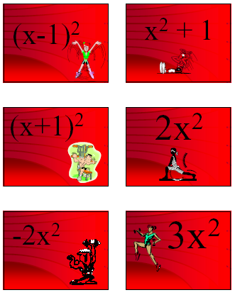
4.2.4 Function Aerobics PowerPoint Presentation File (Teacher) (continued)

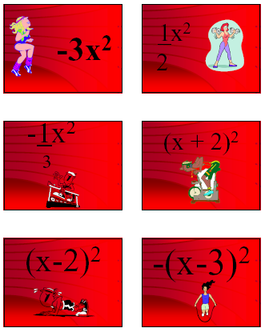
4.2.4 Function Aerobics PowerPoint Presentation File (Teacher) (continued)

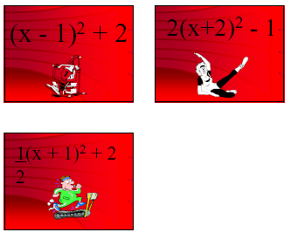

Unit 4 : Day 3 : Sketching Graphs of f(x) = a(x – h)² + k |  |  |  | Grade 11 U/C
Minds On: 15 |  | Description/Learning Goals  - Sketch the graphs of f(x) = a(x – h)² + k by applying one or more transformations to the graph of f(x) = x². |  | Materials  - BLM 4.3.1  - BLM 4.3.2  - Computer & data projector  - Optional: (Music & CD Player)  - Scissors  - Overhead projector  - Acetate sheets  - Chart paper  - Markers
Action: 35
Consolidate:25
Total=75 min
Assessment
Opportunities
 | Minds On… | Whole Class → Demonstration  - Using a computer with data projector, lead function aerobics using the presentation file.  - Students will participate in function aerobics to show their understanding of the roles of a, h, and k in quadratic functions of the form  f(x) = a(x – h)² + k in terms of transformations on the graph of f(x) = x² |  | Clear a large central space in the classroom to allow students to perform function aerobics.  Functions Aerobics.ppt  Optional background music could be used.  Literacy strategy: Think/Pair/Share should be used during the action portion of the lesson.  Teachers should print BLM 4.3.1 on acetate sheets and provide each pair with copies.  Teacher should ensure that all students have an opportunity to use the manipulative in their respective groups.  Teacher should ensure proper use of terminology in student responses.
 | Action! | Pairs → Explore  - Students will explore how to sketch the graphs from the given equations by applying a series of transformations.  - Students record the results on BLM 4.3.2.
 | Consolidate Debrief | Whole Class → Check for Understanding  - Using an overhead copy of BLM 4.3.2 have students demonstrate how they found the graphs. Encourage many pairs of students to participate.  Mathematical Process Focus: Communication (Students will communicate their answers using suitable mathematical vocabulary and using various representations e.g. graphs and verbal descriptions.)
Concept Practice |  | Home Activity or Further Classroom Consolidation  - Assign extra practice questions as needed.

4.3.1 Manipulatives for Investigating the Graphs of Quadratic Functions in Vertex Form (Teacher)


Photocopy the following onto acetate sheets. Each pair is to receive a set of three parabolas. Note: The parabolas have the same scale as grids on BLM 4.3.2.
y = x² | y = 2x² | $$y=\frac{1}{2}x^{2}$$
y = x² | y = 2x² | $$y=\frac{1}{2}x^{2}$$
y = x² | y = 2x² | $$y=\frac{1}{2}x^{2}$$
y = x² | y = 2x² | $$y=\frac{1}{2}x^{2}$$


4.3.2 Investigating the Graphs of Quadratic Functions in Vertex Form

For each quadratic function below you and your partner will:
- Describe the transformations that have transformed y=x² into the given quadratic function.
- Choose the appropriate shaped parabola on acetate and place the parabola on the grid with the vertex at the origin and opening upwards.
- Transform the parabola according to your list of transformations.
- Record a sketch the final parabola on the grid.

Quadratic Function | Transformation(s) | Graph
y = x² + 5 | No stretch or compression  No horizontal translations  Vertical translation of 5 units upwards
y = 2(x – 3)²

$$y=\frac{1}{2}(x+6)^{2}−3$$

4.3.2 Investigating the Graphs of Quadratic Functions in Vertex Form (continued)
Quadratic  Function | Transformation(s) | Graph
y = -2(x + 3)² + 4

y = -(x + 3)² - 6

$$y=−\frac{1}{2}(x+5)^{2}+2$$

y = -3(x – 1)² + 2

Unit 4 : Day 5 : Completing the square using algebra tiles |  |  |  | Grade 11 U/C
Minds On: 15 |  | Description/Learning Goals  - Express the equation of a quadratic function in the vertex form f(x) = a(x – h)² + k, given the standard from f(x) = ax² + bx + c by completing the square, including cases where b/a is a simple rational number, and verify, using graphing technology, that these forms are equivalent representations.  - Students will be able to change from the standard from of a quadratic function to the vertex form of the quadratic function using algebra tiles. |  | Materials  - BLM 4.5.1  - Algebra tiles (one set per pair)
Action: 40 |  |  |  | Materials  - BLM 4.5.1  - Algebra tiles (one set per pair)
Consolidate:20 |  |  |  | Materials  - BLM 4.5.1  - Algebra tiles (one set per pair)
Total=75 min |  |  |  | Materials  - BLM 4.5.1  - Algebra tiles (one set per pair)
Assessment
Opportunities
 | Minds On… | Whole Class → Discussion  - Discuss quadratic functions in vertex form; f(x) = a(x – h)² + k and ask guiding questions:  - What information can we gather from the equation? (i.e. vertex, direction of opening, stretches, compressions)  - How is this information helpful to us?  - How could we rewrite quadratic equations in standard from to vertex form? |  | This is day one of a two-day investigation.  Students would benefit from a review on how to use algebra tiles, especially, what each piece represents, i.e. the dimensions and the area.  Literacy strategy: A tells B  Have partners explain to each other how they completed their square.  You cannot use algebra tiles to complete the square for expressions that have negative coefficients, expressions where “b” is odd, or expressions where “a” does not divide evenly into “b”.
 | Action! | Pairs→ Exploration  - Students will use Algebra Tiles to complete BLM 4.5.1  - Here are some guiding questions for students to think about while they are working on BLM 4.5.1.  - Which one of the tiles represents a square all on its own?  - Does (x+1)² = x² + 1?  - Discuss why is x² + 2x + 1 a square?  - What does the value of a mean in term of algebra tiles  (Answer- Number of squares to build)?  Mathematical Process Focus: Reasoning and Proving (Students use algebra tiles to complete the square, trying different strategies, looking for a patterns and use logical reasoning.)
 | Consolidate Debrief | Whole Class → Discussion  - Have students share their responses from question 2 on BLM 4.5.1  - Possible guiding questions:  - What observations can we draw from your experience with the algebra tiles?  - Discuss limitations of algebra tiles
Reflection |  | Home Activity or Further Classroom Consolidation  - Teacher to assign further questions as needed.  - Have students write in their journals. Using the following prompts:  - Why is completing the square an appropriate name for the procedure of converting a quadratic function into vertex form?  - What types of quadratic expressions cannot be “completed” using algebra tiles? |  | The second journal prompt will be a transition to the algebraic procedure for completing the square in the next lesson.

4.5.1 Completing the Square – Algebra Tile Investigation

Recall the values of each of the algebra tiles. The value of the tile is its area. We will only be working with positive (red tiles) representations of algebraic expressions.

 |    | 
x² Tile  Area = x • x = x² units | x Tile  Area = 1 • x = x units | Unit Tile  Area = 1 • 1 = 1 unit

Your Task: With a partner, complete the following investigation.
1. Complete the table on the next two pages using algebra tiles.
- Represent each expression using the appropriate number of each of the algebra tiles.
- Using the tiles you selected, try to create a square of tiles. When doing so, keep the following rules in mind:
- You may only use one x²-tile in each square.
- You must use all the x² and x-tiles. Unit tiles are the only ones that can be leftover or borrowed.
- If you need more unit tiles to create a square you have to “borrow” them. The number you borrow will be a negative quantity.
- You may create multiple squares, but they must have the same size

2. After you have completed the table, answer the following questions:
- What strategy did you use to place the x tiles around the x² tile?

- Can you create a square with an odd number of x tiles?

- What is the relationship between the value of “a” and the number of squares you created?

- What is the name of the form for the combined expression in the last column?

- Why is “Completing the Square” an appropriate name for this procedure?

4.5.1 Completing the Square – Algebra Tile Investigation (continued)
Standard Form | Number  of x² Tiles | Number  of x Tiles | Number of Unit Tiles | Sketch of the Square | Length of the Square | Area of the Square  (Length)² | Unit Tiles  Left Over (+) Borrowed (-) | Expression Combining Previous Two Columns
x² + 2x + 3 | 1 | 2 | 3 | 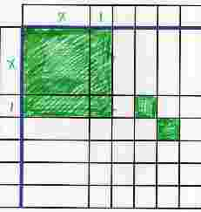 | x+1 | (x+1)² | 2 | (x+1)² + 2
x² + 4x + 1 |  |  |  | 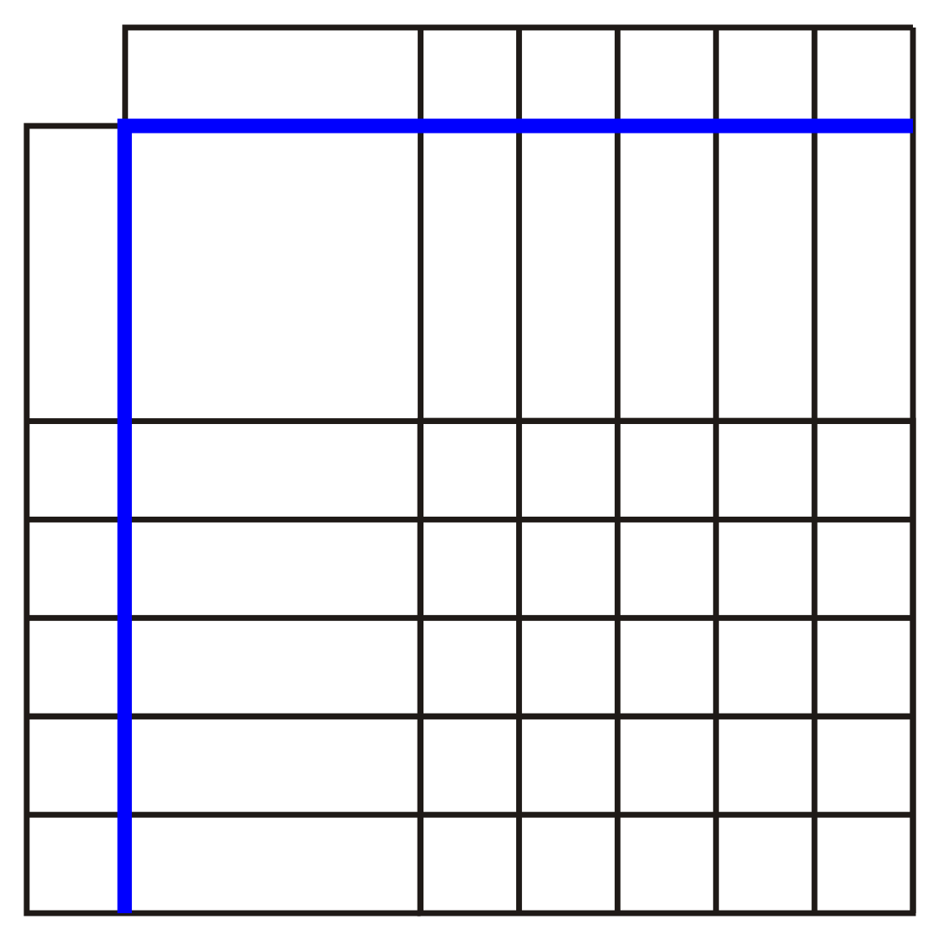
x² + 6x + 8
4.5.1 Completing the Square – Algebra Tile Investigation (continued)
Standard Form | Number  of x² Tiles | Number  of x Tiles | Number of Unit Tiles | Sketch of The Square | Length of the Square | Area of the Square  (Length)² | Unit Tiles  Left Over (+)  Borrowed (-) | Expression Combining Previous Two Columns
2x² + 4x + 5

3x² + 18x + 12
2x² + 8x + 7

Unit 4 : Day 6 : Completing the square using algebra |  |  |  | Grade 11 U/C
Minds On: 15 |  | Description/Learning Goals  - Express the equation of a quadratic function in the vertex form f(x) = a(x – h)² + k, given the standard from f(x) = ax² + bx + c by completing the square, including cases where $\frac{b}{a}$ is a simple rational number, and verify, using graphing technology, that these forms are equivalent representations.  - Students will be able to abstractly change from the standard from of a quadratic function to the vertex form of the quadratic function. |  | Materials  - BLM 4.6.1  - Graphing calculators  - FRAME document
Action: 40
Consolidate:20
Total=75 min
Assessment
Opportunities
 | Minds On… | Whole Class → Discussion  - Lead a discussion where the characteristics of quadratic functions that can and cannot use algebra tiles to complete the square are listed. Organize the characteristics using a mind map.  Pairs → Investigation  - In pairs, students will complete questions 1 - 4 of BLM 4.6.1 using results from BLM 4.5.1 and graphing calculators. |  | For characteristics see lesson 5.  Literacy Strategy  Mind Mapping  (Think Literacy: Cross-curricular Strategies Grades 10-12, p 32)
 | Action! | Whole Class → Discussion/Guided Instruction  - Have students share their procedures for completing the square. Consolidate their ideas into an agreed class procedure.  - Proposed guiding questions;  - What is the same and what is different in the two forms of the equation?  - What is the relationship between “h” and “b”?  Pairs → Practice  - Students practice completing the square using the class procedure by completing question 5 on BLM 5.6.1. Partners will correct each other’s work.
 | Consolidate Debrief | Individual → Create Graphic Organizer  - Students will summarize the procedure for completing the square algebraically by using a graphic organizer such as a flowchart.  Mathematical Process Focus: Representing (In their journals, students will represent the procedure for completing the square using a graphic organizer)
Concept Practice  Reflection |  | Home Activity or Further Classroom Consolidation  Assign extra practice questions as needed.  Update FRAME graphic organizer document with information from the last two lessons.

4.6.1 Completing the Square – Algebraic Procedure

Instructions:
- Copy the vertex form of the expressions from BLM 4.5.1 into column two below.
- Using a graphing calculator, graph the expression in standard form and vertex form on the same graph. What do you notice about the two graphs? Record your observations in the Observations/Findings column of the table.
- With your partner, propose a procedure for changing a quadratic function in standard form into the vertex form based on your findings. Record your response in the Observations/Findings column of the table.
- Discuss your observations with your partner. Your teacher will ask you to share your ideas with the class.
- Once your class agrees on a procedure, fill in the last column of the table by completing the square using the procedure the class agrees on.

Standard Form | Vertex Form | Observations/ Findings | Completing the Square Algebraically
x² + 4x + 1

x² + 6x + 8

2x² + 4x + 5

3x² + 18x + 12

2x² + 8x + 7

Unit 4 : Day 9: “CAS”ing out the quadratic formula |  |  |  | Grade 11 U/C
Minds On: 15 |  | Description/Learning Goals  - To review solving simple quadratic equations  - Explore the algebraic development of the quadratic formula with technology  - Use various methods to solve quadratic equations |  | Materials  - BLM 4.9.1  - BLM 4.9.2  - BLM 4.9.3  - BLM 4.9.4  - Scissors  - Glue or tape  - CAS enabled calculator
Action: 40
Consolidate:20
Total=75 min
Assessment
Opportunities
 | Minds On… | Pairs → Activity (Review of Solving Quadratic Equations)  Students complete BLM4.9.1 using a Think/Pair/Share strategy. |  | Students are not required to be able to develop the quadratic formula.  Literacy Strategy:  During Minds On use the Think, Pair, Share strategy. During Consolidate use the Round Table strategy.  (Think Literacy: Cross-curricular Strategies: Gr 7-9, p 96)
 | Action! | Pairs → Activity (Putting the Pieces in Order)  Students are presented with a quadratic equation that cannot be solved by factoring or other known methods. Thus a new method is introduced. Students apply their prior knowledge of completing the square to this new situation by correctly sequencing the steps that solve this type of quadratic equation. Refer to BLM4.9.2  Whole Class → Demonstration (“CAS”ing Out the Quadratic Formula)  Teacher will first solve a numerical example of a quadratic equation using the CAS enabled calculator. Teacher will then connect the steps of the numeric example to the development of the quadratic formula. Students are only expected to follow the demonstration using BLM4.9.3.  Mathematical Process Focus: Reasoning and Proving (Students will reason by correctly sequencing the steps in developing the quadratic formula.)
 | Consolidate Debrief | Small Groups → Consolidate  Using a Round Table cooperative learning literacy strategy (refer to BLM4.9.4), students will practice solving quadratic equations using various methods.
Concept Practice |  | Home Activity or Further Classroom Consolidation  Assign extra practice questions as needed.

4.9.1 Review of Solving Quadratic Equations

Working with a partner, solve and check the equations given. If Partner A has solved the equation, partner B will check it and vice-versa, until all the equations have been solved and checked.
PARTNER A | PARTNER B
Solve:  x – 5 = 0 | Check:
Check: | Solve:  x² = 25
Solve:  x² + 9 = 25 | Check:
Check: | Solve:  (x – 2)² = 25
Solve:  (x – 2)² + 9 = 25 | Check:
Check: | Solve:  4(x – 2)² + 9 = 25

4.9.2 Putting the Pieces in Order

All of the quadratic equations from the previous activity could be solved by isolating the variable. Sometimes it is not possible to solve by isolating the variable. Another method is required.
We must perform the following steps:
- Group the variable terms on one side and constant terms on the other side of the equation
- Complete the square
- Factor into a perfect square
- Solve for x

Example:

The equation x² –10x – 3 = 0 has been solved by using the method of completing the square. However, the steps are not in the correct order. Working with a partner, cut out the steps given and rearrange them in the correct order. Glue these pieces in the space provided on the next page.



x² + 10x + ${\left(\frac{\text{10}}{2}\right)}^{2}$= 3 + ${\left(\frac{\text{10}}{2}\right)}^{2}$

(x + 5) = ±√28

x = 0.29 or x = -10.29

x² + 10x – 3 = 0

(x + 5)² = 28

x² + 10x - 3 + 3= 0 + 3

x² + 10x = 3

x² + 10x + 5²= 3 + 5²

x² + 10x + (5)² – (5)² = 3

x = -5 ± 5.29

4.9.2 Putting the Pieces in Order (continued)

GLUE YOUR STEPS HERE:

Using completing the square to solve a quadratic equation:

Note: How would one check the solutions to this equation?

4.9.3 “CAS”ing Out the Quadratic Formula

As you may have noticed, applying the method of completing the square will solve any quadratic equation in the form of ax² + bx +c = 0, but it is a tedious and repetitive process. Luckily, because it is so repetitive, the process can be generalized into a formula and then this formula can be quickly and easily applied to solve any quadratic equation, no matter how complicated it may look. In a sense, the quadratic formula is the “nutcracker” for solving all quadratics!!

In this activity you will follow the development of the quadratic formula as shown through the use of a very powerful calculator. This calculator allows the inputting of instructions common to algebra, such as “factor” and “expand”. This calculator is called a CAS (Computer Algebra System) – enabled calculator. The model name of the calculator is either a TI-89 or TI-92.

Part A: In this activity you will follow the use of a Computer Algebra System (CAS) to solve a quadratic equation by completing the square. Use the screen shots to guide your work. The screen shots are from the TI-92.

Description of Process | Guiding Screen Shots
Try to factor the trinomial 2x² + 8x - 9 = 0 using your TI-89 or TI-92 by pressing F2 and selecting 2:factor(  After the opening bracket, enter the equation you are trying to solve, followed by a closing bracket. Press ENTER  Note: When entering an equation, be sure to enter “*” when multiplying a coefficient with a variable (ex. 8x should be entered as 8 * x ) | 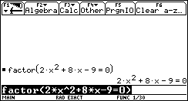
In solving this quadratic equation by completing the square the first step is rewrite the equation so that the variable terms are on one side of the equation and the constant term on the other.  Thus, eliminate the constant term, which is -9, from both sides of the equation by  entering “+ 9” (without the quotation marks) on the calculator, then press ENTER. | 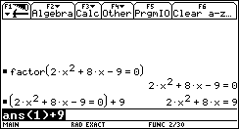

4.9.3 “CAS”ing Out the Quadratic Formula (continued)

Description of Process | Guiding Screen Shots
Next, divide both sides of the equation by the coefficient of the x² term. In this case, enter “÷ 2”. Press ENTER | 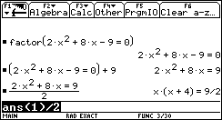
Next, expand the equation to separate all the terms. To do this press F2 and selecting 3:expand(. Use the arrow up key and select the equation by pressing ENTER. Don’t forget to close this equation with an end bracket “)”. Press ENTER. | 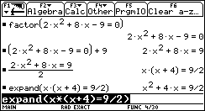
Next, is to write in a term that completes the square on the left side of the equation. To do this we add an amount that is half of the coefficient of the x-term, squared, to both sides of the equation.  In this case, enter “+(4/2)^2”. Press ENTER | 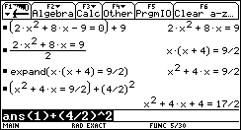
Next, factor both sides of the equation by pressing F2 and selecting 2:factor( Use the arrow up key and select the equation by pressing ENTER. Don’t forget to close this equation with an end bracket “)”. Press ENTER. | 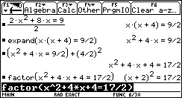

4.9.3 “CAS”ing Out the Quadratic Formula (continued)

Description of Process | Guiding Screen Shots
Next, take the square root of both sides by press the √ (2nd → X), then selecting your equation by scrolling up and pressing ENTER. Close your brackets and press ENTER. | 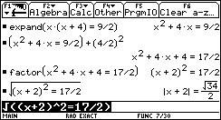
Next, solve for x by pressing F2 then select 1:solve( by pressing ENTER. Use the arrow up key and select the equation by pressing ENTER. Then enter , x ). | 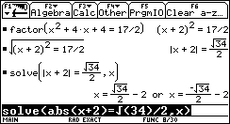
What are your solutions? | x = _____ OR x = ______

4.9.3 “CAS”ing Out the Quadratic Formula (continued)

Part B: Now we are ready to develop the quadratic formula. We will repeat the steps used above except this time we will apply them against the general form of the quadratic equation: ax² + bx + c = 0

Specific Numeric Example | General Form Example
 | 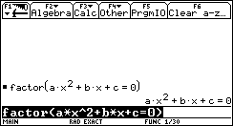
 | 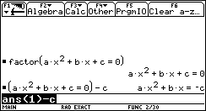
 | 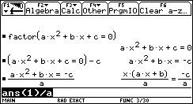

4.9.3 “CAS”ing Out the Quadratic Formula (continued)

Specific Numeric Example | General Form Example
 | 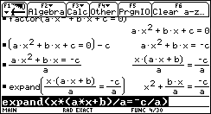
 | 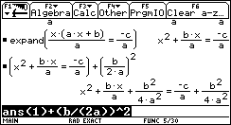
 | 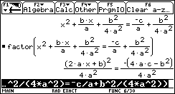
 | 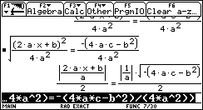

4.9.3 “CAS”ing Out the Quadratic Formula (continued)

Specific Numeric Example | General Form Example
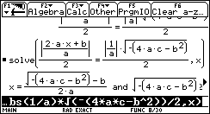
Full Screen Below
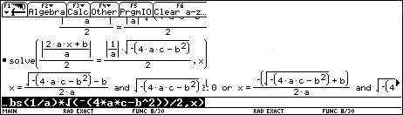

Wow, you’ve just developed the quadratic formula!

The Quadratic Formula is:

$$x=\frac{−b±\sqrt{b^{2}−4\text{ac}}}{2a}$$

This will solve the general quadratic equation in the form

ax² + bx + c = 0

4.9.4 The Quadratic Round Table (Teacher)

In this exercise, students will practice solving quadratic equations using a structure called “Roundtable”

Organize students into teams of 4 with desks facing each other.

One sheet of paper is used per question, per team.

Write out a question that is to be solved on the board or overhead.

The goal is to have each team solve the quadratic, one step at a time, by having each student take turns in writing a step and passing the paper on to the next member of the team.

Incorrect responses should be noted and corrected by other team members. This constitutes one turn for that member.

When the team is satisfied that the quadratic has been solved, they should raise their hands and the teacher will write their final answer on the board.

Answers can then be compared as a class.

Possible quadratics to be solved:

- 0 =4x² – 3x –2
- 5x² = -3x – 1
- 4(x – 5)² = 8
- 3x² – 6x = 0
- –8x² – 5x +2 =0
- (x –4)(x+2)=0

Notes:
- Some of these quadratics are solved more efficiently without the use of the quadratic formula. One can use this fact as a quick assessment of whether students are able to select different tools when solving quadratics.
- Whether to ask students to state exact or approximate solutions to a desired number of decimal places is left open to the teacher. This may be a good point for a class-wide discussion.
- This may or may not be done in a “race” format, depending on the group dynamics of the cass.

Unit 4 : Day 12 : The Nano Project or Fuel Fit Activities |  |  |  | Grade 11 U/C
Minds On: 15 |  | Description/Learning Goals  - Collect data from a primary or a secondary source that can be modelled as a quadratic function without the use of technology.  - Display the data in tabular, graphical and algebraic forms without the use of technology |  | Materials  - BLM 4.12.1  - BLM 4.12.2
Action: 40 |  |  |  | Materials  - BLM 4.12.1  - BLM 4.12.2
Consolidate:20 |  |  |  | Materials  - BLM 4.12.1  - BLM 4.12.2
Total=75 min |  |  |  | Materials  - BLM 4.12.1  - BLM 4.12.2
Assessment
Opportunities
 | Minds On… | Whole Class → Discussion (Nano Project or Fuel Fit)  Teacher sets the context for either activity by posing either of the guiding questions below (refer to BLM 4.12.1 or BLM 4.12.2)  Nano Project-If you are selling a product and want to maximize your income what factors do you have to consider?  OR  Fuel Fit-What factors influence fuel economy while driving? |  | There are two investigations to choose from:  The Nano Project (BLM4.12.1) uses a primary data source  or  Fuel Fit (BLM4.12.2) uses a secondary data source.  Ask: Which model, numerical or graphical, is easiest to use when looking for trends in data?  Reference for Fuel Fit:  http://scholar.lib.vt.edu/theses/available/etd-122898-094232/unrestricted/ETD.pdf  http://cta.ornl.gov/data/tedb25/Spreadsheets/Table4_22.xls
 | Action! | Small Groups → Investigation (Nano Project or Fuel Fit)  Teacher conducts survey as described in BLM 4.12.1 then students will complete the table and investigate the relation between price and income.  OR  Students will investigate the relation between fuel consumption and speed (BLM4.12.2).  Mathematical Process Focus: Connecting (Students will connect real-world data to mathematics. Students will represent the data in tabular, graphical and algebraic forms.)
 | Consolidate Debrief | Whole Class → Discussion  Teacher could pose the following questions:  - How would your graph change if fewer data values were used?  - If student council had to pay a flat fee of $500 to purchase the Nanos, how would the graphical model be affected?
Application  Concept Practice  Reflection |  | Home Activity or Further Classroom Consolidation  Graph fuel consumption versus speed for cars in 1984. Determine an algebraic equation that models this curve. What speed offers optimal fuel consumption

4.12.1 The Nano Project


The student council of your school is going to sell 4GB iPod Nano MP3 players to support the purchase of a school van. The council is interested in determining what a student would pay for each Nano to maximize their income. Your class has been selected as the sample for this study

The survey of your class will be conducted in this manner:

Your instructor will call out a dollar figure starting at $0 and increasing in increments of $10 up to $300.
- For each amount that you would be willing to pay for the Nano, raise your hand. You may raise your hand for more than one price until you have reached your limit.
- After each increment, your instructor will count the votes and you will record this figure in the table below under the column titled Frequency.
- You must calculate the Income column by multiplying the Frequency by the Purchase price.
- Since pictures are worth a thousand words, you will determine a graphical model of the data manually. This will be a scatter plot of Income vs. Purchase Price.
- Finally, you will determine an algebraic model that describes the trend of the data.

iPod Purchase Survey (Raw Data)

Purchase Price  per iPod ($) | Frequency | Income  ($) |  | Purchase Price  per iPod ($) | Frequency | Income  ($)
0 |  |  |  | 160
10 |  |  |  | 170
20 |  |  |  | 180
30 |  |  |  | 190
40 |  |  |  | 200
50 |  |  |  | 210
60 |  |  |  | 220
70 |  |  |  | 230
80 |  |  |  | 240
90 |  |  |  | 250
100 |  |  |  | 260
110 |  |  |  | 270
120 |  |  |  | 280
130 |  |  |  | 290
140 |  |  |  | 300
150

4.12.1 The Nano Project (continued)

iPod Purchase Survey (Scatter Plot)

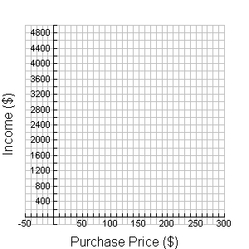

4.12.1 The Nano Project (continued)

Determining the “Best” Purchase Price

You will now determine what purchase price will maximize income.

Collect Coordinates to create An Algebraic Model:
- Draw a curve that best ‘fits’ the trend of your data and identify the type of function.
- Record the coordinates of at least 5 points on the curve. Be sure to include the coordinates of the intercepts and the point where income is maximized.
- Record your data points in the table below:

Purchase Price  Per Nano ($) | Income ($)

- Create three algebraic models:

Factored Form | Vertex Form | Standard/Expanded Form
y = a(x – r)(x – s)  Solve for a by substituting the x-intercepts for r and s and the value of any other point for x and y.  So, the equation of the quadratic in factored form is: | y = a(x – h)² + k  Solve for a by substituting the vertex for h and k and the value of any other point for x and y.  So, the equation of the quadratic in vertex form is: | y = ax² + bx + c  Expand either the factored or vertex form to rewrite the equation in standard/expanded form.  So, the equation of the quadratic in standard/expanded form is:

4.12.1 The Nano Project (continued)

Analysis:

The student council requires the following information.

Determine which quadratic form is most suitable to find the requested information. Place a check mark in this box. Then provide a calculation that provides an answer for the requested information

Requested  Information | Factored Form | Vertex Form | Standard/Expanded Form
At which price(s) is/are the income from the Nano sales is $1000
At which price(s) is/are the income from the Nano sales zero
If the purchase price of the Nano is $105, predict what would the income be
At which price is the income from the sales maximized

- Compare your algebraic models with that of another group. Are they the same? Give reasons for any differences.

- Explain why the graph would rise and then fall (increase then decrease)?

4.12.1 The Nano Project (Teacher)

Sample Data

Purchase Price per Nano ($) | Frequency | Income  ($)
0 | 30 | 0
10 | 30 | 300
20 | 30 | 600
30 | 30 | 900
40 | 30 | 1200
50 | 30 | 1500
60 | 26 | 1560
70 | 24 | 1680
80 | 24 | 1920
90 | 20 | 1800
100 | 20 | 2000
110 | 20 | 2200
120 | 19 | 2280
130 | 17 | 2210
140 | 15 | 2100
150 | 12 | 1800
160 | 11 | 1760
170 | 10 | 1700
180 | 10 | 1800
190 | 9 | 1710
200 | 5 | 1000
210 | 2 | 420
220 | 1 | 220
230 | 0 | 0
240 | 0 | 0
250 | 0 | 0
260 | 0 | 0
270 | 0 | 0
280 | 0 | 0
290 | 0 | 0
300 | 0 | 0

4.12.2 Fuel Fit (Teacher)

In the near future you may be interested in getting your driver’s license. With a partner answer these questions. Be prepared to share your answer.


Jot down ways of reducing fuel consumption.

If you are concerned about gas consumption, is it best to have a high
value (maximum) for km/L or a low value (minimum) km/L. Explain your reasoning.

4.12.2 Fuel Fit (continued)

The following data relates speed to fuel consumption based on an average of 9 different vehicles (http://cta.ornl.gov/data/tedb25/Spreadsheets/Table4_22.xls).

Speed (km/h) | Fuel Consumption, Year 1973  (km/L) | Fuel Consumption, Year 1984  (km/L) | Fuel Consumption, Year 1997  (km/L)
24.2 |  | 8.8 | 10.2
32.2 |  | 10.7 | 11.7
40.3 |  | 12.6 | 12.8
48.3 | 8.8 | 13.3 | 13.3
56.4 | 8.8 | 14.1 | 13.1
64.4 | 8.8 | 14.1 | 13.0
72.5 | 8.5 | 14.0 | 13.2
80.5 | 8.2 | 13.3 | 13.6
88.6 | 7.7 | 12.7 | 13.6
96.6 | 7.3 | 11.5 | 13.1
104.7 | 6.8 | 10.4 | 12.2
112.7 | 6.2 | 9.4 | 11.2
120.8 |  | 8.4 | 10.4

- Make a scatter plot Gas Consumption vs. Speed for 1997.
- Draw the curve of best fit
- What type of function models the curve of best fit?

4.12.2 Fuel Fit (continued)

Gas Consumption (Scatter Plot)

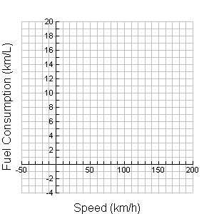

4.12.2 Fuel Fit (continued)

Determining the Optimal Driving Speed

You will now determine what speed you should drive a vehicle to maximize fuel consumption.

Collect Coordinates to create An Algebraic Model:
- Draw a curve that best ‘fits’ the trend of your data and identify the type of function.
- Collect the coordinate of at least 5 points on the curve. Be sure to include the coordinates of the intercepts, the high point (vertex).
- Record your data points in the table below:

Speed (km/h) | Fuel Consumption  (km/L)

- Create three algebraic models:
Factored Form | Vertex Form | Standard/Expanded Form
y = a(x – r)(x – s)  Solve for a by substituting the x-intercepts for r and s and the value of any other point for x and y.  So, the equation of the quadratic in factored form is: | y = a(x – h)² + k  Solve for a by substituting the vertex for h and k and the value of any other point for x and y.  So, the equation of the quadratic in vertex form is: | y = ax² + bx + c  Expand either the factored or vertex form to rewrite the equation in standard/expanded form.  So, the equation of the quadratic in standard/expanded form is:

4.12.2 Fuel Fit (continued)

Analysis:

The Ministry of Transportation wants you to make predictions using your algebraic models.

Determine which quadratic form is most suitable in find the requested information. Place a check mark in this box. Then provide a calculation that provides an answer for the requested information

Requested  Information | Factored Form | Vertex Form | Standard/Expanded Form
At which speed(s) is fuel consumption 12km/L

At which speed(s) is fuel consumption zero

If the speed is 60 km/h, predict the expected fuel consumption
Which speed gives the optimal fuel consumption

- Compare your algebraic model with that of another group. Are they the same? Explain.

- Explain why the graph would rise and then fall (increase then decrease)?

4.12.2 Fuel Fit (continued)

3. You are planning 500 km trip from Parabola Ville to Quadraborough.
  - Using what you learned from this activity, sketch the relationship between Gas Consumption (km/L) and Speed (km/h).

Speed (km/h)

  - Predict the relationship between total cost in dollars of this trip and the speed at which this trip has been driven.

Speed (km/h)

Unit 4 : Day 13 : The TI-Nano Project or Fathom Fuel Fit Activities |  |  |  | Grade 11 U/C
Minds On: 15 |  | Description/Learning Goals  - Generate curves of best fit using technology  - Determine the equation of the curve using technology  - Compare different algebraic forms of quadratic equations |  | Materials  - BLM 4.13.1  - BLM 4.13.2  - BLM 4.13.3  - Graphing calculators  - FRAME document  OR  - Computer lab
Action: 40
Consolidate:20
Total=75 min
Assessment
Opportunities
 | Minds On… | Whole Class → Four Corners Activity (BLM 4.13.1)  Teacher reads the context to the class and writes the first algebraic model on the board. Based on the algebraic model given, students decide on an answer and move to that corner. Teacher then posts the next algebraic model and students have the opportunity to revise their answers. Repeat for the last model.  Note: Read the equations in the order given |  | There are two lessons for the teacher to choose. TheTI-83 Nano Project uses a primary data source and Fathom Fuel Fit uses a secondary data source.  Teachers can use the file Fuel Fit Sliders.ftm which contains data and sliders.  Literacy Strategy:  During Minds On use the Four Corners strategy to review and consolidate the previous lesson.  (Think Literacy: Cross-curricular Strategies Grades 10-12, p 106)
 | Action! | Individual → Investigation (The TI-Nano Project or Fathom Fuel Fit)  Students will use BLM4.13.2 to guide an investigation using technology on the TI-Nano Project  OR  Students will use BLM4.13.3 to guide an investigation using technology on the Fathom Fuel Fit  Mathematical Process Focus: Representing (Students will represent applications of quadratics, graphically and algebraically using technology)  Selecting Tools and Computational Strategies (Students will use appropriate technology to display and analyse quadratic models)
 | Consolidate Debrief | Pairs→ Discussion  Students compare their summary tables and revise if necessary.  Whole Class → Discussion  Pose the following guiding questions:  - Which algebraic model of the quadratic function would you use to find the y-intercept?  - Which algebraic model of the quadratic function would you use to find the zeros (x-intercepts)?  - Which algebraic model of the quadratic function would you use to find the maximum or minimum value of the function?
Reflection |  | Home Activity or Further Classroom Consolidation  In their journal, students write their response to:  “What are the benefits/drawbacks of using technology versus pencil and paper methods when determining quadratic models?”  Students can update their FRAME graphic organizer document for quadratic functions with new information acquired in the last two lessons.

4.13.1 Four Corners Activity (Teacher)

In today’s activity, the teacher will read a problem involving quadratics and the students must move to one of the four labelled corners in the classroom.

Example 1:
Which ordered pair best describes the initial position of the ball?
1  (4, 0) |  | 2  (2.25, 6.125)
A football is thrown from below sea level. It’s height (m) versus time (s) is modeled by the following algebraic equations:
y = -(2x – 1)(x – 4)
y = -2(x – 2.25)² + 6.125
y = -2x² + 9x – 4
(0, -4)  3 |  | Not Sure  4

Example 2:
Which ordered pair best describes the maximum height of the ball of the ball?
1  (4, 0) |  | 2  (2.25, 6.125)
A football is thrown from below sea level. It’s height (m) versus time (s) is modeled by the following algebraic equations:
y = -2x² + 9x – 4
y = -(2x – 1)(x – 4)
y = -2(x – 2.25)² + 6.125
(0, -4)  3 |  | Not Sure  4

4.13.2 The TI-83 Nano Project


In today’s activity, you will be revisiting the Nano Project. Last class you generated an equation for your curve of best fit using pencil and paper. Today, you will generate your algebraic equation using technology.

- Enter your data from your table into the lists in the graphing calculator. To do this press STAT→ENTER.
- In the L1 column enter the Purchase Price per Nano values. Omit the data that contains zero frequency.
- In the L2 column enter the Income values. Omit the data that contains no income.
- Setup the scatter plot by pressing: 2nd→Y= (STAT PLOT)→ENTER. Turn on the plotting function moving your cursor to ON and pressing ENTER. Make sure your screen looks like the one below where Xlist is L1 and Ylist is L2. To get to L1 and L2 on your calculator press 2nd→1 (L1) for L1 and 2nd→2 (L2) for L2.
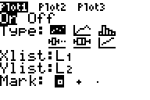
- To see your scatter plot, press ZOOM→9:ZoomStat . The scatter plot should appear on your screen.
- To get the algebraic equation from the calculator press STAT→scroll to CALC→5:QuadReg→L1 → , →L2→ , →VARS→scroll to Y-VARS→ENTER→ENTER→ENTER. Your screen should look like:

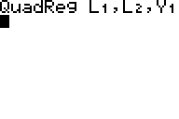
- Record the values of a, b and c that appear on your screen:

a = ___
b = ___
c = ___

- Using your values of a, b and c write the standard/expanded form of the quadratic equation below:

y = ___x² + ___x + ___

- You can view a graph of the equation and your scatter plot by pressing GRAPH
- Estimate the vertex using the TRACE key and use the value of “a” from step 7 to write your equation in vertex form.

4.13.2 The TI-83 Nano Project (Continued)

- Another way of finding the vertex is to use the maximum function of the graphing calculator. The keystrokes are: 2nd→TRACE→4:maximum→ENTER. For the Left Bound scroll the arrow to just left of the maximum point on your graph then press ENTER. For the Right Bound scroll the arrow to just right of the maximum point on your graph the press ENTER-ENTER. Record this ordered pair below. Use the value of “a” from step 7 to write your equation in vertex form.

- Compare the equations you have found in step 10 and 11.

- Summary Table

Quadratic Models Using The Graphing Calculator
Factored Form | Vertex Form | Standard/Expanded Form
y = a(x – r)(x – s) | Using TRACE:  y = a(x – h)² + k | y = ax² + bx + c
y = a(x – r)(x – s) | Using the maximum command on the TI83:  y = a(x – h)² + k | y = ax² + bx + c
Quadratic Models From Pencil and Paper Methods (Refer to previous lesson)
Factored Form | Vertex Form | Standard/Expanded Form
y = a(x – r)(x – s) | y = a(x – h)² + k | y = ax² + bx + c

- What should student council sell each Nano to maximize income? Compare this value to the value you found previously from the scatter plot.

4.13.3 Fathom Fuel Fit

In today’s activity, you will be revisiting the Fuel Fit Activity. Last class, you generated an equation for your curve of best fit using pencil and paper. Today, you will generate your algebraic equation using technology.

- Enter your data from your table into Fathom by clicking and dragging the table icon into the main workspace area.

- Type Speed and FuelConsumption (using Fathom, no spaces are allowed between words)in the newly added table by clicking <new>.
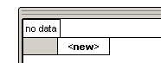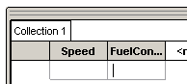

- Type in the data in to the table cells. Do not include the data that contains zero frequency.

- To create a grid drag the Graph icon 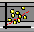 to the main window.

- To graph the data click-hold-drag-drop the Speed attribute column to the x-axis of the graph. Repeat this process for the FuelConsumption but drop it on the y-axis of the graph.

- You must now set the domain and range of the graph. To do this, double click on the x-axis which will then display a dialog box. Change the domain of the speed axis to start from -20 and end at 200. Do the same for the FuelConsumption axis with numbers starting from -2 and end at 18.

- You will find the optimal fuel consumption surface by estimating a quadratic equation for this data. Your equation will be in vertex form: y=a(x - h)² + k.

- To create this equation you will need to make 3 Sliders for the parameters a, h and k. To create a slider click on Insert→Slider from the menu. Change the name from V1 to a by typing over the text. Repeat this for h and k. Position the sliders under the graph.

4.13.3 Fathom Fuel Fit (Continued)

- Adjust the sliders range so that the value of the vertex will be included in the range of values. This can be done by placing the cursor over the x-axis of the slider then double clicking it when the hand appears. A slider axis information window then appears. To change the min/max value of the window, double click on the old value and type in a new value.
- Use the following ranges for your sliders:
  - Use -0.1 to 0.1 for the range of a
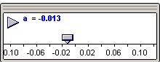
  - Use 0 to 200 for the range of h
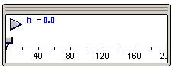
  - Use 0 to 20 for the range of k
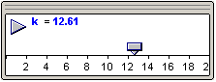

- To graph your function first select the graph by clicking on it, then select Plot Function from the Graph menu. Now enter the equation a x (Speed - h)² + k, then click OK.

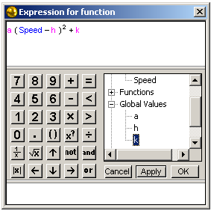

4.13.3 Fathom Fuel Fit (Continued)

- Fit the curve to the scatter plot using your sliders.

- Once you are satisfied with the fit of your curve, record the values of a, h and k:

a = ___ h = ___ k = ___

- Write your equation in vertex from. What is the vertex? Compare it to the one you found by pencil-and-paper method.

- Summary Table:

Quadratic Models Using Fathom
Factored Form | Vertex Form | Standard/Expanded Form
y = a(x – r)(x – s) | y = a(x – h)² + k | y = ax² + bx + c
Quadratic Models From Pencil and Paper Methods (Refer to previous lesson)
Factored Form | Vertex Form | Standard/Expanded Form
y = a(x – r)(x – s) | y = a(x – h)² + k | y = ax² + bx + c

- At what speed should you drive to optimize fuel consumption? What is the optimal fuel consumption?

4.13.3 Fathom Fuel Fit (Teacher Answer Key)

